**Brooklyn torah gazette**

**For parshas chukas 5779**

Volume 3, Issue 45 (Whole Number 141) 10 Tammuz 5779/ July 13, 2019

**Printed L’illuy nishmas Nechama bas R’ Noach, a”h**

For a free subscription, please forward your request to [***keren18@juno.com***](mailto:keren18@juno.com)

**Rabbi Yosef Mizrachi’s**

**Recipe for a Better Life**

**Today and Eternally**

**By Daniel Keren**

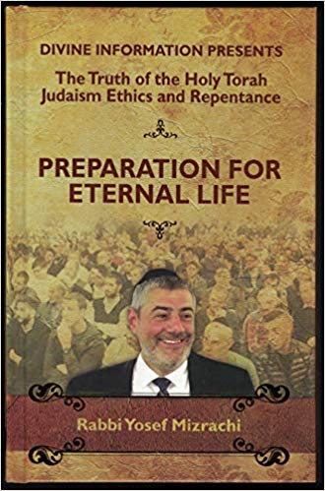

(“Preparation for Eternal Live: The Truth of the Holy Torah and Judaism Ethics and Repentance – Adapted from Thousands of Lectures Given Worldwide by World Renowned Speaker Rabbi Yosef Mizrachi, Divine Information, 241 pages, 2019)

Rabbi Yosef Mizrachi is not an overnight sensation in the Jewish world. The Israeli-born resident of Monsey has been travelling all over the world for almost a quarter of a century in order to inspire Jews of all backgrounds of the dire importance of leading lives based of Torah Jewish values or face the tragedy of discovering after their short sojourn in Olam Hazeh (this temporary world) that they have lost out on the incredible true pleasures G-d wants to bestow on mankind – Eternal Life.

**Grew Up in a Secular Israeli Home**

Over the course of many years of speaking out on how the truth of the Torah as a document given to the Jewish people can be verified and how the other major world religions can be proven to be false man-made philosophies, Rabbi Mizrachi who grew up in a secular home in Bat Yam, Israel (near Tel Aviv and served in the Israeli Air Force) has dramatically impacted the lives of tens of thousands of Jews and non-Jews alike.

Many if not most of his lectures have been posted on his website [www.DivineInformation.com](http://www.DivineInformation.com) and over the last few years on the American website TorahAnytime.com, thus making his theological concepts available to a wider audience than the many thousands who are able to attend in person his various lectures or Shabbaton programs during the course of a single year.

**Influencing Many Through His**

**Personal and Recorded Lectures**

In most of his appearances, Rabbi Mizrachi makes it a point to distribute free CDs and DVDs of his many lectures on various topics in the hopes that some who take them will listen and be inspired to change their lives for the better and as a result become Torah Jews aiming to develop a clear connection to Hashem.

Adapted from thousands of lectures given around the world is a condensed 241 page book that was published in the hopes of helping his many listeners around the globe and also for his thousands of fans to give as gifts to others in the hope that they too will be challended ask themselves the important question of what their purpose in life is and why did G-d put them into this world.

**New Book is a Mind Opener**

**For Many Secular Jews**

Reading Rabbi Mizrachi’s new book “Preparation for Eternal Life” which follows shortly after the publication of his original Hebrew edition can be a mind opener for many Jews raised in the very secularized attitudes of Western Civilization that dominates America, Israel, Europe and other similar cultures. Basically his theme is that one who is addicted to the hedonistic pleasures of Olam Hazeh can’t escape the consequences of rejecting G-d’s blue print for life – the Torah [which also is important for non-Jews in that they too have an obligation to observe the basic Seven Noahide laws.]

Don’t think, Rabbi Mizrachi writes that you can simply opt out for the rewards of Eternal Life in the Next World (Olam Habah.) It is not like a job where if you don’t perform at par you will at best be fired and not paid. At worst, in addition to not getting paid for doing the mitzvahs which was the purpose of your coming down into this world, one will be severely punished eternally for failing to do his or her tafkid (purpose.)

**A Clarification Regarding the Purpose**

**Of Life…Faith and Trust in G-d**

On the back cover of the book, the goal declares: “The book PREPARATION FOR ETERNAL LIFE offers the reader plentiful advice, words of encouragement, and clarification regarding the purpose of life, the pursuit of truth, character improvement, faith and trust in G-d, laws of proper conduct between man and his fellow, between man and the Creator, observing the commandments, marriage, marital harmony, livelihood, etc.”

And the best part of it is that even if up until now you have either not been keeping the Torah or at best observing the Torah like a mindless robot, all is not lost. As long as you are still alive, Rabbi Mizrachi writes it is never too late to do teshuva (repentance). Quoting from the prophet Ezekiel/Yechezkel (33:11), Rabbi Mizrachi reminds the reader:

**G-d Does Not Desire the Death of the Wicked**

**But Rather That He Repent and May Live**

“As I live – word of the L-rd (Hashem) – [I swear] that I do not desire the death of the wicked one, but rather the wicked one’s return from his way, that he may live. Repent, repent from your evil ways! Why should you die, O House of Israel.”

There are those who shy away from bitter-tasting medicines. But if it can save your spiritual life, why not consider it. “Preparation for Eternal Life” is written in an easy-to-read and understandable manner by a charismatic speaker who has devoted to the last quarter of a century of life to help rescue his fellow Jews around the world from spiritual suicide. If your bookstore doesn’t stock this book it can be ordered by clicking www.DivineInformation.com

*Reprinted from the July 4, 2019 edition of The Jewish Connection.*

**Rav Avigdor Miller on**

**Being Decent without Torah**

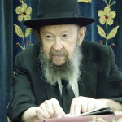

**QUESTION**: Why isn't it good enough to just be a decent and good person? Why do I have to follow all the rules in the Torah?

**ANSWER:** The answer is, why must we keep traffic laws? Isn't it good enough to be decent and good person? Do you realize how many good people go through red lights?! Do you realize how many good people have killed innocent persons by driving while drunk?!

Good intentions are not enough to make you a good person. A man must be bound by a code to be decent - and if he's choosing a code, he may as well take the very best code there is.

Don't fool yourself; there's no such thing as a good person without Torah. A good person can be a homosexual and a pervert. A good person can be a mercy killer - he kills his own mother because he cannot bear to see her suffer. A good person can be a selfish man who thinks he's doing good, when the reality is that he's only helping himself because he's blinded by his own desires.

We have to know that nobody is able to live with the standards that he himself creates. You see that 50 years ago, the Reformers, the Reform Jews, had certain standards that they considered good and moral. And yet today, they have changed entirely. So whatever people consider the standards of good and decent in one generation can change in another generation. It's only those who live by the eternal standards of the Torah who remain good forever and ever.

*Reprinted from the june 21, 2019 email of Toras Avigdor (Tape #E-121).*

**The Shmuz onParshas Chukas**

**Davening: The Third System**

**By Rabbi Bentzion Shafier**

**Founder of TheShmuz.com**

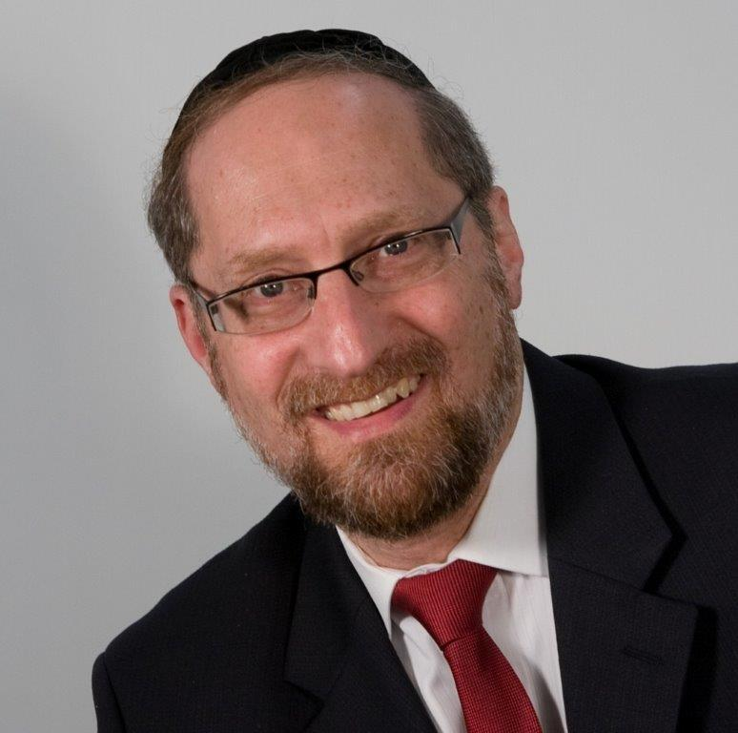

“*And the Canaanite king of Arad who dwelled in the south heard that Israel had come by the route of the spies, and he waged war against Israel and took a captive from it.*” — Bamidbar 21:1

**The Reputation of Yisrael**

When HASHEM took the Jewish nation out of Mitzrayim with an “outstretched arm,” most of Creation welcomed the news as a defining moment in history. The nation of Amalek, however laid plans to attack Yisrael.

The posuk describes the “Canaanite king” who sat in the south and heard that Yisrael was coming. But Rashi points out that it wasn’t the Canaanite nation that lived in the south of Israel; it was Amalek. Why are they referred to as the “Canaanite?”

Rashi answers that according to the Medrash, the nation that attacked was Amalek. However, when they came close, they stopped speaking their mother tongue and switched to the language of Canaan. Their reasoning was that the Jews would hear them speaking and would assume that it was Canaan that was attacking them.

The Jews would then daven to HASHEM to save them “from Canaan.” Since these opponents were not from Canaan, the tefillah wouldn’t work. But their plan failed because the Jews recognized something unusual. Yes, their enemies were speaking the language of Canaan, but they were dressed as Amalekim. Therefore, the Jews davened in neutral language: “HASHEM, save us from this nation.” As a result, their tefillah was effective.

**The Question**

It is clear from this Rashi that had the Bnei Yisroel davened incorrectly and said, “HASHEM save us from Canaan,” their tefillah would not have worked. However, they were saved because they realized the trick and davened in a manner that included all possibilities.

This Rashi is very difficult to understand. What difference would it make what expression the Jews used? HASHEM would know what they meant. The Jewish nation was in trouble, faced with an enemy attacking, and they called out to their Creator. Why would it matter whether they referred to the attackers as Canaan or Amalek? HASHEM would know what they were referring to, and if they were worthy of being saved, HASHEM would listen.

The answer to this question cuts to the very underpinning of how prayer works.

**Why Daven?**

One of the most basic question that a person should ask about tefillah in general is “Why should we daven?” HASHEM is the ultimate Giver. HASHEM is infinitely more generous and benevolent than any person. He loves every one of His creations more than we can ever imagine.

That being said, why should we ask HASHEM for anything? If what we are asking for is truly good for us, then HASHEM would have given it to us already. And if it isn’t good for us, why should we ask for it?

The answer to this question is based on understanding that tefillah functions in three distinct systems.

**The Growth System**

The first is the “**growth system.**” By davening, we change ourselves. Tefillah is a method that allows us to recognize certain truths and to live them.

The reality is that we mortals get caught up in the ways of nature and tend to forget that HASHEM is present and that it is He who runs the world. When we need something and recognize that we are incapable of filling that need that forces us to reach out to our Creator.

We then come to the core realization that He alone is in charge. That process changes us and helps us grow. So, it could well be that before we davened, we weren’t worthy of having our requests granted, but via the process of davening we **changed**, and now we merit it. For this reason, HASHEM will often hold back things specifically so that man should ask because that is what he needs to grow. This is the first system of prayer, whereby a person changes as a result of davening.

**The Mercy System**

The second system of davening is the “**mercy system**.” Our relationship with HASHEM is that of a child to a father. HASHEM loves us and has great compassion on us. The second system of davening takes advantage of that relationship. We call out to HASHEM to help us not because we are worthy, but rather as a son who calls out to his father and asks him to have mercy. This system recognizes that may we may well not be worthy of receiving that which we ask for, not before davening nor after, but we ask HASHEM to overlook who we are and to give us what we need. We attempt to arouse the middah of rachamim.

**The Avodah System**

Chazal tell us that HASHEM said to Moshe, “I will teach you something that you will need to know as the leader of this nation. There will be times when the Jewish people will be in trouble, and even their own merit and the merit of the Avos will not help them. When this happens, you are to call out the thirteen attributes of HASHEM. Say the words, ‘HASHEM, HASHEM Kel rachum v’chanun. . .’ and I will forgive their sins.”

The question is: how does this work? The Klal Yisroel didn’t change via that tefillah. They didn’t become more worthy because of it, and if it is just an issue of arousing HASHEM’s mercy, why those specific words said in that specific manner?

The answer to this is that HASHEM created certain systems of avodah that affect the world. Just as there are laws of nature and physical actions that affect the world, so too HASHEM created an upper world, and various actions affect it. In the time of the Bais HaMikdash, if a person lived through a Yom Kippur, the korbonos of that day brought him forgiveness.

Even if he wasn’t attuned to what was going on, even if he wasn’t in Yersuhalayim, and even if he slept through the entire day, just the fact that he was alive while the Kohain Gadol did the avodah brought him a certain level of forgiveness for his sins.

However, there are certain rules to the system. The process is demanding and exact. Any deviation and it doesn’t work. Much like an otherwise-perfect radio can’t function if it is missing just one transistor, so too in the avodah. Any missing detail and the system doesn’t function.

This seems to be the answer to this Rashi. The Amalekim were very sophisticated and were aware of the powerful functioning of the upper world, and they did their best to interrupt the Jews’ use of that system. They tried to trick the Jews so that they would daven incorrectly and thereby negate the third system of tefillah, which might have made all the difference as to whether the tefillah worked.

Even though the Jews davened with kavannah and HASHEM knew what they meant, that tefillah would not have carried the full power because it was inaccurate and couldn’t utilize the third system of davening.

This concept is very relevant to us. While we strive to make our davening passionate and vibrant, the reality is that there will be occasions when we will find it difficult to concentrate or to feel a real emotional connection to HASHEM.

It is at those times that we need to remember that Chazal used a highly defined system to create the tefillos that we say. The effect of the words themselves, is well beyond anything that we can imagine. While it is not the ultimate goal in davening, just mouthing the words can have a huge impact and change our destiny.

*Reprinted from this week’s website on TheShmuz.com This is an excerpt from the [Shmuz on the Parsha book](https://theshmuz.com/product/shmuz-on-the-parsha-book/).*

**The Secret of the Copper Snake**

**And Transforming Evil into Good**

**From the Talks of the Lubavitcher Rebbe**

**Rabbi Menachem Mendel Schneerson, Zt”l**

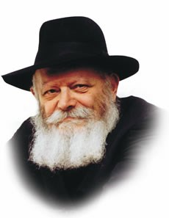

This week's Torah portion, *Chukat*, describes the Jewish people's impatience with their long journey through the desert. Despite the manna from heaven, the fresh water from Miriam’s well and the Clouds of Glory which protected them wherever they went, they were dissatisfied.

Why did you bring us up out of Egypt to die in the wilderness? they complained.

Because of their ingratitude, G-d sent a plague of fiery serpents to punish them. The serpent, to whom all food has the same taste, became the vehicle for punishment against those who complained that the manna, which acquired any taste the individual desired, was insufficient. The fiery snakes, so called because their poisonous venom burns like fire, bit the people, and many died.

Chastised, the Jews came to Moses and admitted that they had sinned. They begged him to pray to G-d to remove the terrible plague from their midst. G-d's answer to Moses' prayer was the following: Make for yourself a fiery serpent, and set it upon a pole...everyone that is bitten--when he sees it--he shall live.

Moses followed G-d's command and fashioned a serpent out of copper (*nechoshet* in Hebrew, from the same root word as serpent *nach-ash*), and set it high upon a pole where it could be easily seen. The Torah tells us that when an afflicted person looked up at the serpent, he was healed and did not die.

Rashi, the great Torah commentator, explains that merely looking at the copper serpent was not enough. A person had to look up in the spiritual sense as well, accepting the yoke of heaven and subjugating his heart to G-d above. Only then would the bitten person be restored to health.

The serpent itself, symbolic of the primordial serpent in the Garden of Eden, responsible for bringing evil into the world, alludes to this concept of transforming the negative into the positive. The bitten person had to subjugate his whole heart, the evil as well as the good inclination, and dedicate his entire being to the service of G-d.

Another example of this concept, the transformation of evil into a positive force for good, is also found in the beginning of the Torah portion. The ashes of the red heifer, although making unclean whoever prepared them, brought purity to the sinner on whom they were sprinkled.

This is the goal of every Jew to utilize both of our inclinations in the service of G-d and serve Him with a whole heart.

*Reprinted from the Parashat Chukat 5753/1993 edition of L’Chaim Weekly (Issue #263), a publication of the Lubavitch Youth Organization in Brooklyn, NY.*

**Rabbi Berel Wein on**

**Parashat Chukat**

The climax of the tragedies that have been recorded for us in the previous readings of the Torah appears in this week’s reading. Driven to anger and exasperation, Moshe disobeys the order of G-d to speak to the rock and extract water from it and instead he raises his staff and smites it a number of times. This act does produce water, but it leads to the confirmation of the fact that neither Moshe nor Aharon will lead the Jewish people into the land of Israel.

The prophecy of Eldad and Meidad, that Moshe will die in the desert and that Joshua will lead the Jewish people into the land of Israel is now proven to be bitterly accurate. There is much discussion amongst the commentators as to why Moshe is so severely punished. In the review of the story of the Jewish people while in the desert of Sinai that appears in the book of Dvarim, Moshe himself seems to indicate that it was somehow for the benefit of the Jewish people itself.

He apparently could no longer be the leader of the people when they entered the land of Israel and found themselves in completely different circumstances than those that pertained while living in the desert of Sinai. There is no doubt that all later Jewish history would have taken a different course had Moshe lived and led the Jewish people into the land of Israel. But the will of heaven always pertains and creates the circumstances and narrative in which we ordinary mortals must function and somehow succeed.

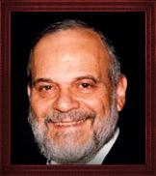

**Rabbi Berel Wein**

Maimonides saw in this narrative of the Torah the effects of cumulative behavior. By this he meant that Moshe was not judged and punished for the sin of striking the rock but rather this act was the final misdeed of his career. Because of his greatness and position of leadership, he was held to an exacting, exalted criteria of behavior. This judgment and the punishment that befell him was an accumulation of all the minor mistakes he had made.

If we will attempt to understand what the transgression was and if the punishment fit the crime, we will always come up short of explanations that truly satisfy our human sense of logic and rectitude. The ultimate lesson of the narrative of this incident is that the judgment of Heaven always remains beyond our scrutiny and understanding.

Moshe was warned early on that in spite of his greatness and holiness and though there would never be another human as close to Heaven and possessing his powers of prophecy, he still would not be able to truly fathom and understand the ultimate judgment, so to speak, of Heaven.

Eventually Moshe comes to terms with this reality and understands that the dividing line between the Creator and the created can never be crossed. This is one of the most important messages that this week’s reading can teach us.

*Reprinted from this week’s website of Rabbiwein.com*

**These Too Are From Sinai**

**By Rabbi Moshe Meir Weiss**

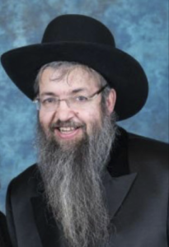

With the help of Hashem, several years ago I completed writing a commentary on bentching.  (As an aside, if you are interested in purchasing this bencher, please call me at (718)-916-300 or email me at [RMMWSI@aol.com](mailto:RMMWSI@aol.com).)

As the bencher went through the rigorous editing process, I found something that all proofreaders are very allergic to: starting a sentence with the word, ‘And.’

In the world of proofreading, that is almost a capital offense. Yet Hashem not only starts a sentence with ‘And,’ He starts an entire parsha with this word, for Parshas Mishpatim starts off, “V’Eileh HaMishpatim – And these are the laws.”

Why does Hashem make this grammatical exception? Rashi explains that this is an example of the connecting vav, which acts as a bridge to connect the subject of mishpatim, words of Jewish jurisprudence, to the subject matter mentioned earlier, namely the Ten Commandments.

In the words of Rashi, “Mah harishonim miSinai af eilu miSinai – Just like the Ten Commandments were taught at Sinai so too the laws that govern our co-existence with our fellow man were also taught at Sinai.”  This lesson however is puzzling, for wasn’t the whole Torah given on Sinai?  What novelty does this connecting vav impart to us?

I believe that Hashem put it there for the sake of emphasis.  It is to teach us that if someone leaves a shovel sticking in the ground halfway buried in the snow and someone else stumbles upon it, he commits a Torah prohibition on the same scale as wearing shatnez.

Similarly, if he sees a lost article of his enemy and refrains from picking it up, it’s just as criminal as eating a piece of pork.  The shopkeeper who assures the customer that his price can’t be beat when he knows that one can get it cheaper at Wal-Mart or Target is transgressing, “Midvar sheker tirchak,” which is just as bad as missing zman Krias Shema.

As the saying goes, we have to be just as concerned for a “bloodstain” on our money as we are for a bloodstain in our eggs. It is for this reason that the great Rav Yehudah HaNasi, author of the Mishnah, chose to start Pirkei Avos, Ethics of Our Fathers, with the preface, “Moshe kibeil Torah miSinai,” that Moshe accepted the Torah from Hashem at Mount Sinai.

We would think that the message that the Oral Law is also Divine should’ve been placed at the very beginning of the Mishnah, at the start of Masechtas Berachos. Why did Rebbi wait until deep into Seder Nezikin to inform us of this truth?  Again I believe it was to impress upon us that the laws of human behavior to avoid anger and to spurn haughtiness, to be benevolent and kind, are not simply examples of good common sense but are also of Divine origination from Sinai.

I vividly remember how Rav Avigdor Miller, Zt”l, Zy”a, would caution us about safety issues. He would say that if there is a home with young children and medicine bottles are left around without child resistant caps, the parents are guilty of, “Lo saamod al dam rei’echa – Do not stand idly by your brothers’ blood.”

He would say that if a school had windows without window guards on the second floor in young children’s classrooms, then that school should close down until they make the proper corrections.

Following Rav Miller’s direction, when we built our new shul, the Agudah of Staten Island, twenty-six years ago, I insisted that the shul be built according to all fire codes.  This was expensive but it is the dictate of the Torah and an important lesson to the Baal Habatim.

Rav Miller noted that the Rambam bunches together Hilchos Rotzei’ach with the laws of Shemiras HaNefesh, guarding a soul. Rav Miller explains this is to teach us the important lesson that if one doesn’t take proper precautions not to cause harm to others, it is tantamount to murder.

Thus, if one leaves the metal doors to their basement open in front of their shop and a passerby falls down the concrete steps to the basement below, he is guilty of negligent manslaughter.  Rav Miller adds the novelty that even if day after day no one falls, he has still repeatedly committed the crime of lo saamod al dam rei’echa.

May it be the will of Hashem that we attach as much importance to these laws as we do to such laws as not eating a mixture of meat and milk, and in that merit may we be blessed with long life, good health, and everything wonderful.

*Reprinted from the January 30, 2016 website of Matzav.com*

**What the Popularity of ‘Shtisel’ Tells Us About the Non-Orthodox Majority**

**By Daniel Treiman**

NEW YORK ([JTA](http://jta.org/)) — Would the builders of New York’s Temple Emanu-El ever have imagined that their congregation’s sanctuary would one day be packed to the balconies with thousands of devout followers of a black-hatted Orthodox rabbi and his family?

That was the scene last week when the citadel of high Reform Judaism on Manhattan’s Upper East Side was overtaken by “Shtisel”-mania.

Fans of the Israeli TV series about the day-to-day dramas of a haredi — that is, ultra-Orthodox — family in Jerusalem filled the Fifth Avenue synagogue to see the show’s three stars discuss their surprise Netflix-streamed hit. Demand was so intense that the organizers — Emanu-El’s Streicker Center, The Jewish Week Media Group and UJA-Federation of New York — added a second night when the first quickly sold out. Some 4,600 attended over the two nights, according to the event’s sponsors.

The “Shtisel” stars had just come from two events in Los Angeles and would soon head across the Hudson to another synagogue event in New Jersey. Wherever they went, excited fans followed, some flying in from far away to hear from their small-screen heroes.

The first night at Temple Emanu-El, the three “Shtisel” actors — Dov Glickman, who played family patriarch Shulem Shtisel; Michael Aloni, who played his son Akiva; and Neta Riskin, who played daughter Giti — and show producer Dikla Barkai seemed as surprised as anyone at their show’s success, marveling at the crowd of thousands assembled before them.

They recounted their more modest initial expectations for the show. Aloni said that “Shtisel” did not exactly have the hallmarks of an international hit: There were no sex scenes or car chases.



**“Shtisel” has a certain voyeuristic appeal to some Jewish viewers. (Netflix/Dori Media)**

“We all shared this feeling that we were doing something great that no one would watch,” he said.

Yet this quiet show about private family dramas in Jerusalem’s insular haredi community made a big splash. In Israel, where “Shtisel” first aired in 2013, its popularity bridged the secular-religious divide. Its two seasons cleaned up at the Israeli Television Academy awards, while TV-less haredi Jews found ways to watch avidly and surreptitiously.

But it wasn’t until Netflix picked up the show in December that “Shtisel” got a second life as an international sensation. Now there are plans for a third season (though the show’s producers might need to work out a deal with the Israeli Actors’ Association over sharing overseas sales revenue) and also for an American version set in Brooklyn.

The popularity of “Shtisel” first became apparent to me when I realized that everyone in my tiny Orthodox shul seemed to be watching it. But I didn’t fully appreciate what a phenomenon the show had become until a nonreligious friend who is uninvolved in organized Jewish life told me that “Shtisel” was one of the only shows she had watched in the past two years.

“Shtisel” fandom is not a parochial allegiance. Look no further than a 13,000-member Facebook group devoted to the show, where fans from across the country and around the world — Jews and non-Jews of varied religious backgrounds — probe the show’s depths and obsess over its minutiae, from analyzing its handling of bereavement to gushing over Aloni’s good looks.

To what does “Shtisel” owe its popularity? For starters, it’s just excellent TV: superbly written, well acted, with compelling characters and rich story lines. There’s also, no doubt, a certain voyeuristic appeal: an opportunity to gaze into a mysterious and cloistered world.

For many Jewish viewers, I suspect, curiosity about our haredi kin is a significant part of the show’s attraction. We non-haredi Jews can appreciate that haredim are connected to us, that they are, in some sense, our mishpocha. Yet our connection to the haredi world is attenuated by a profound religious chasm. “Shtisel” allows us to bridge that divide from the comfort of our couches.

That’s because the show’s themes are deeply relatable: love, longing, loss, fidelity and infidelity, filial and parental responsibility, conformism and rebellion, and dreams, both chased and crushed. (Dreaming is a central motif, with depictions of dreams lending a magical element to a series rooted in its characters’ earthly struggles in a community defined by fear of heaven.)

“Shtisel” is fundamentally about its characters’ relationships played out within the confines of their community. The outside world intrudes only sparingly — the American soap operas enjoyed by Shulem’s mother, much to her pious son’s dismay; the overheard roar of a military air show on Israeli Independence Day; the “damned evil people,” a phrase invoked by Shulem’s brother Nuchem to decry unseen but hostile outsiders.

Even Akiva, whose dream of a career as a painter is scorned by his father — a religious scholar with a low regard for any arts that are not culinary — but encouraged by a secular patron, keeps the nonreligious world at arm’s length. Aloni in his remarks at Temple Emanu-El was adamant that leaving the haredi world was never a consideration for his character.

While “Shtisel” is a show about a haredi family, Judaism is not the show’s subject. It is, rather, the show’s context. For the entire first season, we do not so much as see the inside of a synagogue. But every aspect of the Shtisels’ everyday lives is suffused with Jewishness, from the way the characters dress to the words they use to the way they greet one another to the blessings they utter before they take a sip of water.

This is one way in which “Shtisel” differs from the recent bumper crop of shows with Jewish protagonists. A Jewish story line in a show about American Jews might involve going to synagogue (as in “Transparent”), going to Israel (“Transparent” again), going on Birthright (“Broad City”) or going to a Palestinian chicken restaurant (“Curb Your Enthusiasm”). It requires stepping out of the day to day. After all, most American Jews live lives that in most respects are not so different from those of our non-Jewish neighbors. For us, Jewishness is more of a subject than a context. We need to *act* to be Jewish. On “Shtisel,” they need to simply *be****.***

The show’s characters inhabit a thick and rich Jewish context. And that is what makes the universal human stories at the heart of “Shtisel” into a great Jewish drama.

*Reprinted from a June 17, 2019 dispatch of the JTA (Jewish Telegraphic Agency.)*

**“But the Children of**

**Korach Did Not Die”**

**By Rabbi Gideon Schulman**

Happy are those who dwell in Your house; they forever praise You. Selah. Why am I starting with the opening line from Ashrei? Because this line unlike the rest of Tehilla le David, which we are obliged to say three times a day, is attributed to the sons of Korach – the villain of this week’s parsha.

In fact, the Gemara (Bava Basra 14b) lists the sons of Korach among the ten authors of Tehillim and there are many more attributed to them. They are even considered to be the forefathers of Shmuel HaNavi.

Unlike their father, the sons of Korach managed to survive being swallowed by the earth, with the pasuk stating: “and the earth opened its mouth, and swallowed them up together with Korach, as that company died, as the fire devoured two hundred and fifty people, and they became a sign. But the children of Korach did not die” (Bamidbar 26:10-11).

So how did the sons of Korach come so far from their roots? Did we not read the following over Shavuos a few weeks ago: "For I Hashem your G-d am an impassioned G-d, visiting the guilt of the parents upon the children, upon the third and upon the fourth generations of those who reject Me". (Shemos 20:5)

According to Rashi, Korach’s sons were swallowed up with the rebels, but at the last moment repented. A sanctuary appeared before them and they took refuge. Hashem gave them a chance based upon the faint glimmer of hope that teshuvah entered their thoughts.

So can teshuvah enable us to shake off both our own sins and those of our fathers? The prophet Yechezkel (18) brings to our attention that there is a misconception in this area. He says: “But suppose this son has a son who sees all the sins his father commits, and though he sees them, he does not do such things. He will not die for his father’s sin; he will surely live.”

Ibn Ezra adds that the remembering of sins until the fourth generation should be seen positively: “perhaps the sinner will repent, or, perhaps a child will be born who is better than the father”. This means that rather than being held to the actions of our fathers, whether or not our sins are remembered depends on our own actions.

We can derive many messages from this. Firstly, Hashem never gives up on us – he saved the sons of Korach on the smallest glimmer of hope of their teshuvah. Secondly, no one is beyond the scope of redemption and we can turn around the worst situation to use as a force for greatness. Korach’s sons came within an inch of being trapped in gehinnom to writing words that Jews all over the world say as part of our prayers every day.

While our lives are not usually quite so dramatic, we all have things that we wish we had done differently. May we all reflect on what lessons we can learn from the past and what good we can do as a result for ourselves, for our families and for our community.

*Reprinted from the Parshas Korach 5779 email of Oneg Shabbos from London, England. Please read the next story about Rabbi Gideon Schulman, author of this essay.*

**Living with MS: Hope at Last**

***Gideon Schulman has lived with Multiple Sclerosis for 16 years, and it is gradually worsening. But a new treatment may offer hope, he tells Lauren Libbert.***

Gideon Schulman has never had a down day nor does he ever feel sorry for himself. Not many of us can say such a thing even when gifted with good health, but then Schulman is no ordinary man.

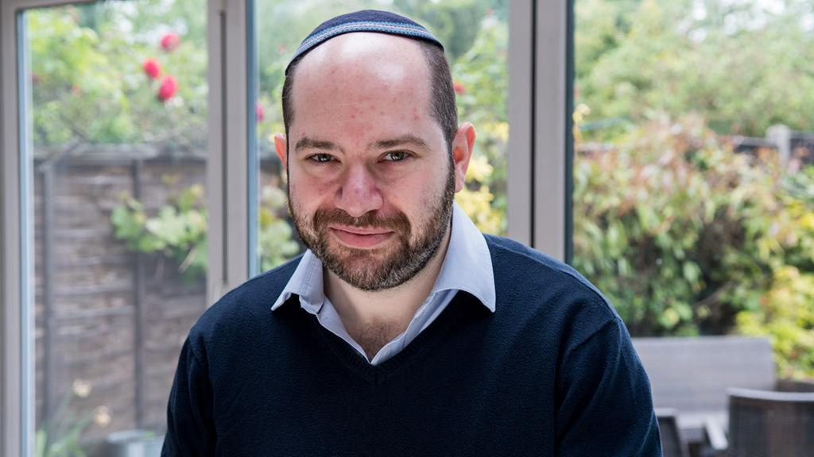

**Rabbi Gideon Schulman**

Diagnosed with Multiple Sclerosis 16 years ago while studying for a masters at Leicester University, Schulman, 39, likens his attitude to the infamous lyrics of *Tub-Thumping* by Chumbawamba: “I get knocked down, but I get up again, you are never gonna keep me down . . .”

“I see people who feel sorry for themselves and it makes them give up on life,” says Schulman, who lives in Hendon. “But I try not to moan about my health. When I wake up in the morning, I put my face on and get on with life and don’t show the world my problems. My feeling is, you’re never given a challenge you can’t cope with and you have to take it on.”

His MS, far from being a punitive life sentence, drives him to appreciate life and makes him less complacent.

“When you can’t walk down the street without thinking about every tiny step in case you fall into a heap on the pavement — which has happened more than once — you start to appreciate every little thing and take nothing for granted,” he says.

Schulman’s MS — now in the progressive, more constant stage of the disease — may have forced him out of his career as a Human Resources director into setting up his own home-care business, but his bucket list of desires are as ambitious as anyone teetering on the precipice of midlife.

His first one — to become a rabbi — was ticked off three years ago; an incredible feat of learning in the face of cognitive and memory challenges, that was recognised and lauded by Chief Rabbi Ephraim Mirvis, Dayan Menachem Gelley and his study partner and friend, Rabbi Chaim Kanterovitz from Borehamwood and Elstree Synagogue.

His second — to become a mentor to young people — was similarly struck off the list recently when he was appointed as one of the governors of Stanmore College of Further Education.“I’m not a pulpit person but being*frum* is about wanting to help and inspire others,” says Schulman, a former trustee of the MS Society. “I have a long career in HR and these skills, plus my MS experience, mean I have a lot to give back. I want to support younger people especially.”

Third on his list is a desire to get married and have children, something he flip-flops with emotionally because of his reluctance to “be a burden” with his deteriorating health. “I’m the one with MS and I don’t want to give that burden to a wife and children,” he says. “Of course I love the idea of settling down but it doesn’t seem fair. I have been out with a number of girls, some of whom called an end to the relationship because of my health, and I don’t blame them for it. In the meantime, I spoil my best friends’ children rotten and, apparently, they adore me, so maybe that has to be enough.”

Also on his bucket list is a desire to play the trumpet — “I have always loved Miles Davis, Louis Armstrong and Dizzy Gillespie. The passion that goes into their music and playing is unbelievable” — and to see the Northern Lights, learn to meditate and to sharpen up his already not-so-bad cooking skills.

“Up until about six months ago, I’d make everything from scratch — hummus, falafel, cakes, challah — and no-one’s died from my efforts yet!” he jokes.

“But now I can’t stand in the kitchen for long periods or hold a knife very well so I’ve had to slow down, which is a shame.”

Schulman’s final entry on his bucket list is especially poignant, in view of the fact his disease is currently rated a six on the disability measure for MS, and by seven, most are in a wheelchair.

“I want to stop MS, particularly mine,” he says. “I am realistic though. Even if they found a cure today, it could be seven or eight years until it went through all the trials and hit the market and that might well be too late for me.”

He hasn’t taken any drugs for years, believing them only to work as a placebo with little research to back them up, but he is impressed with a fairly new treatment — hematopoietic stem cell transplantation (HSCT) — a process that, in effect, wipes and reboots the immune system by harvesting stem cells and using chemotherapy. More than 2,000 people globally have received HSCT with a 75 per cent success rate of halting any further progression of the disease.

Trials are very limited in this country so Schulman has decided to have the treatment in Mexico — “it has a zero per cent fatality rate and that appealed” he jokes — and started fundraising for the £60,000 costs a few months ago. Incredibly, thanks to a number of generous donors, he is now just £7,000 off the final target.

“For the first time since my diagnosis, there’s actual hope,” he says. “It’s created a light at the end of a tunnel. I have a friend with MS who went to Mexico to have the treatment recently and she could barely walk a few metres and now she’s walking 3km a day! I don’t know what will happen for me but to think I might have more of a normal life and get to achieve what’s on my bucket list makes it more than worth a try.”

The treatment will take just under a month and Schulman hopes to go in July.

“It’s meant to be very painful and I have a few friends who insist on being Job’s comforters to prepare me for that side of things but I’m trying not to think about it,” he says.

“For 16 years, I’ve just accepted my diagnosis — that I’d have years shaved off my life and end up in a wheelchair — but this has given me real hope.’

*Reprinted from the June 19, 2017 website of the Jewish Chronicle (United Kingdom).*